[Historic England](https://historicengland.org.uk/)

* [Menu](https://historicengland.org.uk/listing/the-list/list-entry/1431426)
* [Search](https://historicengland.org.uk/sitesearch)
* [Listing](https://historicengland.org.uk/listing/)

Portrait figure of Elisabeth Frink

List Entry Summary

This building is listed under the Planning (Listed Buildings and Conservation Areas) Act 1990 as amended for its special architectural or historic interest.

Name: Portrait figure of Elisabeth Frink

List entry Number: 1431426

Location

West Walk, Harlow, Essex, CM20

The listed structure is shown coloured blue on the attached map. Pursuant to s.1 (5A) of the Planning (Listed Buildings and Conservation Areas) Act 1990 (‘the Act’), structures attached to or within the curtilage of the listed structure (save those coloured blue on the map - a bronze portrait figure of Elizabeth Frink on a concrete plinth) are not to be treated as part of the listed structure for the purposes of the Act.

The building may lie within the boundary of more than one authority.

County: Essex

District: Harlow

District Type: District Authority

Parish: Non Civil Parish

National Park: Not applicable to this List entry.

Grade: II

Date first listed: 19-Jan-2016

Date of most recent amendment: Not applicable to this List entry.

Asset Groupings

This list entry does not comprise part of an Asset Grouping. Asset Groupings are not part of the official record but are added later for information.

List entry Description

Summary of Building

Portrait figure of Elisabeth Frink, 1956 by F E McWilliam, situated off Westgate in Harlow town centre.

Reasons for Designation

The bronze portrait figure of Elisabeth Frink of 1956 by F E McWilliam, situated off Westgate in Harlow town centre, is listed at Grade II for the following principal reasons:   
  
\* Artistic interest: a characterful and affectionate portrait of the renowned sculptor (Dame) Elisabeth Frink by F E McWilliam, a significant sculptor in his own right;  
  
\* Historic interest: an unusual instance of a public sculpture of a woman artist, and an early acquisition by the Harlow Art Trust, representing a programme of public art then rivalled only by the London County Council;  
  
\* Sculptor: a rare full figure portrait sculpture by this significant C20 artist.

History

The period after 1945 saw a shift from commemorative sculpture and architectural enrichment to the idea of public sculpture as a primarily aesthetic contribution to the public realm. Sculpture was commissioned for new housing, schools, universities and civic set pieces, with the counties of Hertfordshire, London and Leicestershire and the new towns leading the way in public patronage. Thus public sculpture could be an emblem of civic renewal and social progress. By the late C20 however, patronage was more diverse and included corporate commissions and Arts Council-funded community art. The ideology of enhancing the public realm through art continued, but with divergent means and motivation.  
  
Visual languages ranged from the abstraction of Victor Pasmore and Phillip King to the figurative approach of Elisabeth Frink and Peter Laszlo Peri, via those such as Lynn Chadwick and Barbara Hepworth who bridged the abstract/representational divide. The post-war decades are characterised by the exploitation of new – often industrial – materials and techniques including new welding and casting techniques, plastics and concrete , while kinetic sculpture and ‘ready mades’ (using found objects) demonstrate an interest in composite forms.  
  
Harlow was designated a new town on 25 March 1947, with Frederick Gibberd devising its master plan and remaining as consultant architect-planner until 1980. He was also one of the first trustees of the Harlow Art Trust, founded in 1953 at the suggestion of Maurice Ash, of the building firm Gilbert-Ash, who donated £250. He was later chairman of the Dartington Hall Trust, whose Elmgrant Trust was an early supporter. At Harlow Ash brought in his friend Sir Philip Hendy, director of the National Gallery, to chair the Trust, with Eric Adams, general manager of the Harlow Development Corporation (HDC), Gibberd, and Patricia Fox-Edwards to represent the local council. The HDC had already commissioned Mary Spencer Watson to make Chiron for the Stow shopping precinct and secured Barbara Hepworth's Contrapuntal Forms and three murals from the Arts Council's dispersal of artworks from the Festival of Britain. Subsequently the Trust concentrated on sculpture for open-air sites, siting works in places where people meet. There is thus a concentration of works in the town centre and at the nodal points of the various neighbourhoods. In 1956 Henry Moore's Family Group was unveiled and by 1957 the Trust had sited ten sculptures. When Sir Philip Hendy retired from the Chairmanship through ill health in 1971 he was succeeded by Mrs Fox-Edwards, later Lady Gibberd.  
  
As the least busy of the four original trustees, Fox-Edwards had toured the graduate shows and minor galleries in search of young sculptors. McWilliam’s portrait figure of Elisabeth Frink, his former student at the Chelsea College of Art, was exhibited in the London County Council (LCC) open-air sculpture exhibition of 1957 and acquired by the Harlow Art Trust with the aid of the Contemporary Art Society. When it was remarked that the sculpture carried no inscription, Frink remarked ‘one can’t be labelled until one is dead’ (Gardiner 1998, pg. 106).  
  
The Northern Irish sculptor Frederick Edward McWilliam (1902–92) was born in County Down and trained at the Belfast School of Art and the Slade School of Fine Art in London, originally studying painting before turning to sculpture in the early 1930s. Early influences included primitive art (particularly African sculpture), his friend Henry Moore, Constantin Brâncusi and Alberto Giacometti, but in 1936 he became associated with the British surrealist group. After war service, he returned to London to teach at the Chelsea and Slade schools, and resumed working in a wide variety of media, including terracotta, stone, wood and bronze. His work is diverse and ranges from broken-surfaced, attenuated figures to portraiture, via surrealistic juxtapositions of body parts; but surprise and wit are often present. His predisposition was to work in series, fully exploring a theme before a radical change in subject and style. McWilliam worked at both large and small scales, and completed a number of public commissions including the Four Seasons group for the Festival of Britain.  
  
Elisabeth Frink (1930-93) was born in Suffolk and studied at the Guildford and Chelsea schools of art. At Chelsea she was taught by McWilliam who became a good friend. Early in her career she received a commission from the Harlow Art Trust resulting in her Wild Boar sculpture. Frink is best known for bronze outdoor sculpture, including the Blind Beggar and Dog, London (1958, Grade II\*); Horse and Rider, Westminster (1975, Grade II) and Desert Quartet at the Montague Shopping Centre, Worthing (1989, Grade II\*). She was elected a Royal Academician in 1977 and awarded a DBE (Dame Commander of the Most Excellent Order of the British Empire) in 1982.

Details

Portrait figure of Elisabeth Frink, 1956 by F E McWilliam, situated off Westgate in Harlow town centre.  
  
This life-size bronze portrait of Elisabeth Frink is approximately 1.83m high and stands on a concrete plinth. Frink is depicted barefoot, wearing jeans and a T-shirt with rolled-up sleeves. The head, turned to one side, with finely modelled facial features and a stylised treatment of the piled-up hair. The hands hang loosely at her sides and the feet are slightly splayed. The rough finish of the piece was created by moulding small pieces of clay from which the bronze was cast. Mounted on the plinth is a small bronze plaque with the inscription 'PORTRAIT FIGURE / by F.E. McWILLIAM / ACQUIRED BY THE HARLOW ART TRUST WITH / THE AID OF THE CONTEMPORARY ART SOCIETY'.

Selected Sources

**Books and journals**  
Ferran, D., Holman, V., The Sculpture of F.E. McWilliam, (2012)  
Gardiner, S., Frink: the Official Biography of Elisabeth Frink, (1998)  
Olsen, D., Sculpture in Harlow, (2005), pp.59-60  
Strachan, W G, Open Air Sculpture in Britain: a Comprehensive Guide, (1984), p.122  
**Websites**  
Mark Sorrell, ‘McWilliam, Frederick Edward (1909–1992)’, Oxford Dictionary of National Biography, Oxford University Press, 2004, accessed 6 November 2015 from<http://www.oxforddnb.com/view/article/51214>  
**Other**  
E. Harwood, 'Sculpture in Harlow', 2015 report in Historic England London Region Historians Files, reference OUT104

National Grid Reference: TL4448509975

Map

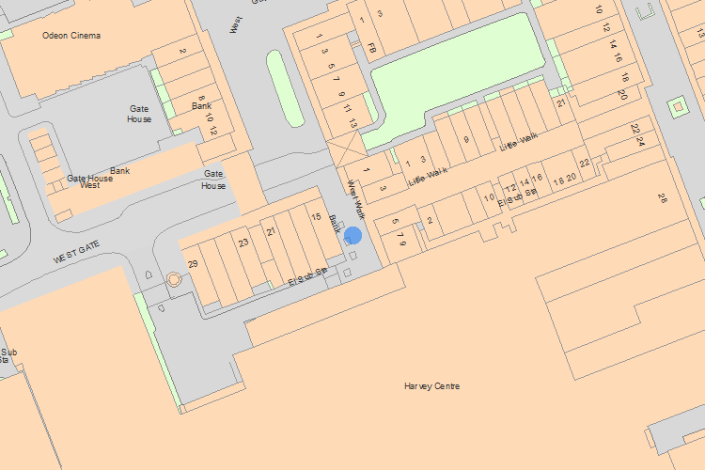© Crown Copyright and database right 2016. All rights reserved. Ordnance Survey Licence number 100024900.  
© British Crown and SeaZone Solutions Limited 2016. All rights reserved. Licence number 102006.006.  
Use of this data is subject to [Terms and Conditions](https://historicengland.org.uk/terms/website-terms-conditions/).

The above map is for quick reference purposes only and may not be to scale. For a copy of the full scale map, please see the attached PDF - [1431426 .pdf](http://mapservices.historicengland.org.uk/printwebservicehle/StatutoryPrint.svc/497008/HLE_A4L_Grade%7CHLE_A3L_Grade.pdf" \t "_blank)

The PDF will be generated from our live systems and may take a few minutes to download depending on how busy our servers are. We apologise for this delay.

This copy shows the entry on 14-Jul-2016 at 11:22:18.

End of official listing

Your Contributions

Do you know more about this entry?

The following information has been contributed by users volunteering for our [Enriching The List project](http://historicengland.org.uk/listing/enrich-the-list/). For small corrections to the List Entry please see our [Minor Amendments procedure](http://historicengland.org.uk/listing/the-list/minor-amendments/).

The information and images below are the opinion of the contributor, are not part of the official entry and do not represent the official position of Historic England. We have not checked that the contributions below are factually accurate. Please see our [terms and conditions](http://historicengland.org.uk/terms/website-terms-conditions/enriching-the-list-contribution-terms/). If you wish to report an issue with a contribution or have a question please email [EnrichingTheList@HistoricEngland.org.uk](mailto:enrichingthelist@HistoricEngland.org.uk).

Top of Form

Email

Password

[Forgotten your password?](https://services.historicengland.org.uk/passportserver/RecoverPassword.aspx)

Log in

Don't have an account? [Sign up](https://services.historicengland.org.uk/passportserver/registration.aspx?app_id=1f8fb93f-56a7-4c10-91e4-6e9d04cbf7aa)

Bottom of Form

There aren't currently any contributions

* [Stay Up To Date](https://historicengland.org.uk/whats-new/stay-up-to-date/)
* [Jobs](https://historicengland.org.uk/about/jobs/)
* [About us](https://historicengland.org.uk/about/)
* [Contact us](https://historicengland.org.uk/about/contact-us/)
* [Accessibility](https://historicengland.org.uk/access/)
* [Terms & Conditions](https://historicengland.org.uk/terms/)

© Historic England 2016